Learning Goals: Students will be able to draw controlling vectors (position, velocity, or acceleration) when the red ball is moving in circles.

Directions:

- I used the Position Arrow control ( selected) to make the Red ball move in concentric circles and the trace of the position vectors looked like Figure 1. Draw what you think the green arrow would have looked like when the red ball was at the locations shown in Figure 2
Figure 1 Figure 2 Figure 3
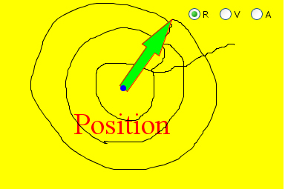

- Use the Practice level of Maze Game with the window maximized for more play area. Check your ideas. Have a partner help you watch the red ball while you control the vector. You can Pause the simulation to help. Make corrections on Figure 3.

- Draw what you think the green arrow would have looked like when the red ball was at the locations shown in Figure 4 and the velocity control was on. Remember that vectors can be drawn anywhere in space, so draw the vector with the tail on each of the red balls to help organize your ideas. Figure 4 Figure 5

- Check your ideas and make corrections on Figure 5.

- Draw what you think the green arrow would have looked like when the red ball was at the locations shown in Figure 6 and the acceleration control was on. Check your ideas and make corrections on Figure 7.

Figure 6 Figure 7

