Lab 11: Wave Interference

INTRODUCTION
Consider the four pictures shown below, showing pure yellow lights shining toward a screen. In 3 and 4, there is a solid wall between the light and screen, with one or two slits cut in to let the light through.
Compare the four scenarios. We are interested in your ideas about what is going on – you will only be graded for effort here. What do you think might be happening to the light to create these different patterns? Discuss with your group and write your ideas in the space below.
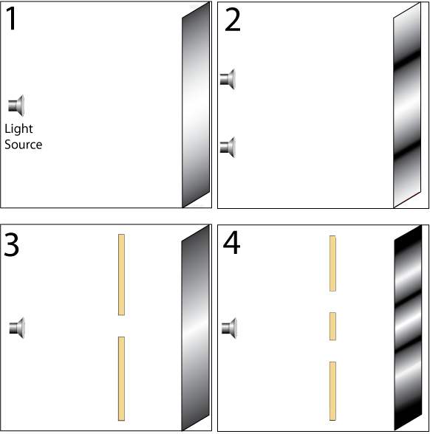
Part 1. Wave Interference Simulation
Open the PhET simulation “Wave Interference.” Explore the simulation to get a feel for the controls.
- Try to recreate the pictures shown on page 1 with the simulation. Describe what you had to do with the simulation to reproduce the pictures.

- Compare what you learned from the simulation to your ideas from page 1. What ideas would you keep? What ideas would you change? (Did you notice the third bright spot right behind the wall in case 4?)

- What happens to the pattern on the screen when the lights are brought closer to each other or farther apart?

- What happens to the pattern when the slits are brought closer and farther apart?

Interference from two slits:
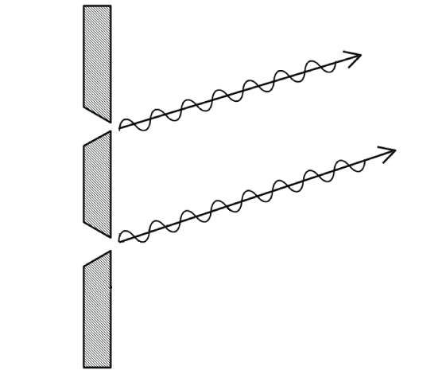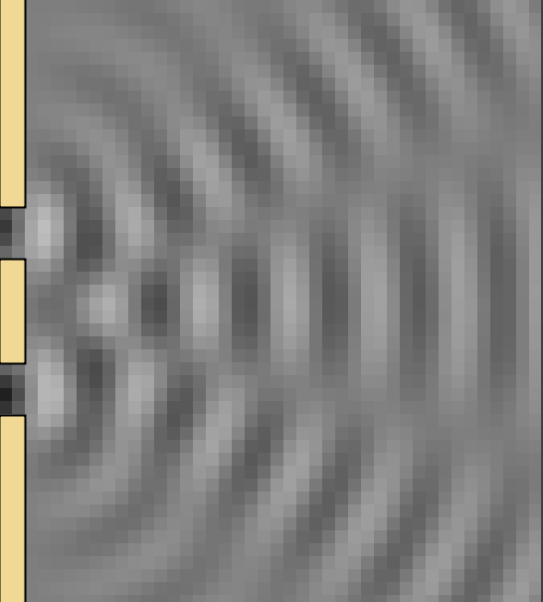
1
2
3

The pictures above show two ways of representing light waves from two slits. Three points are marked 1, 2, and 3 in the picture on the right.
- Predict the brightness of the light you would see on a screen places at points 1, 2, and 3.

- Describe how you might use a picture like the one on the left to support your prediction and explain what is happening at points 1, 2, and 3 on the right. We are interested in your ideas. Write down all the ideas you can think of. You can use the simulation to help you.

Part 2. Double Slit Interference
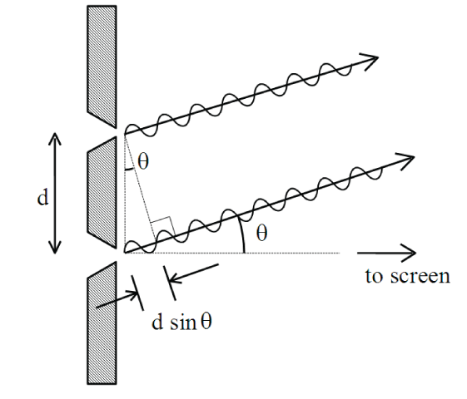
In the pictures on the last page, the rays are emitted in all directions from the slits, but let’s concentrate on the rays that are emitted in a direction θ toward a distant screen (θ measured from the normal to the barrier). One of these rays has further to travel to reach the screen, and the path difference is given by $d\text{sin}θ$.

- Predict the brightness on the distant screen if the path difference is exactly one wavelength λ (or any integer number of wavelengths)? Explain your reasoning.

- Predict the brightness if the path difference is λ/2, 3λ/2, or 5λ/2, etc.?

$\begin{aligned}\left.d\text{sin}θ=mλ | \right\}\end{aligned}\text{ m = 0, }±\text{1, }±2\text{.}\text{.}$Which equation below tells you the angles (θ) at which you will see bright spots and which one tells you the angles (θ) for dark spots?
Circle one: Bright or Dark
Circle one: Bright or Dark
- What ideas from part 1e (page 3) would you keep and which would you revise?

- How do the equations above support your predictions of brightness and the pattern shown on the right?

Small angle simplification: If θ is small (<< 1 rad), then and bright spots occur on the screen at $θ=m\frac{λ}{d}$; dark spots occur at $θ=\left(m+\frac{1}{2}\right)\frac{λ}{d}$.
As shown below, the angle θ (measured from the center of the screen) is related to the distance x measured on the screen by tan(θ)=x/L, where L is the distance from the screen to the source of light (the aperture).

If the angle θ is small (less than a few degrees), then to an excellent approximation, sin(θ) ≈ tan(θ) ≈ θ (in radians) so the locations of the interference bright spots are given by $θ=\frac{x}{L}=m\frac{λ}{d}$.

- What happens to the interference pattern if d is increased? What if d is decreased? Explain your reasoning.

- Are your answers to above consistent with your answers to part 1c and d (page 2)?
PART 3: Diffraction Pattern from Double Slits
The light source in this part of the experiment is a He-Ne laser which produces a monochromatic beam with a wavelength of λ = 632.8 nm. The power output of our lasers is small, but still enough to damage your retina if you look directly into the beam.
NEVER LOOK INTO A LASER BEAM.

The plate you have contains several single, double, and multiple slits. (See figure to the right.) The numbers are those given by the manufacturer and are not always accurate.
Place the plate in its holder and mount it on the optical bench a few centimeters in front of the laser. Place a piece of white paper in the clipboard and place it at the far end of the bench.
- Spend a few minutes exploring. What do you notice? Is it what you expect?

- Just for the double-slits in the plate, list all the things that affect the pattern on the screen.

Part 4. Testing the Plate Specifications
In this part we will test the manufacturer’s specifications for the double-slits in the plate.
- Measure the distance L from the slit to the screen. Record it here:

- How far apart would you expect the peaks in the intensity to be for a slit-spacing of 0.35 mm and λ=632.8 nm? Give the answer both in angle (radians) and in mm using your screen distance L.

- Observe the interference pattern on your paper screen for the double-slit labeled with a separation of 0.35 mm (the one in the middle of the right-most column on the plate). With a pencil, mark the positions of as many of the dark spots that you can see and measure the spacing x between adjacent dark spots on the screen.
What is happening to the light to make the dark spots appear on the screen?

- What measurements do you need to make to allow you to compute the actual slit separation? Record them here.

- Compute d, the actual slit separation. How close is it to the manufacturer’s number? (Within 10%? Within 1%?)

- Compute d, the actual slit separation, for two of the other double-slits in the plate (pick any two). How close are they to the manufacturer’s numbers?

- Based on your measurements, would you buy any more plates from this manufacturer? Why or why not?

- In the Wave Interference simulation, would you say that the flashlight is drawn to scale? If it was drawn to scale, how big would the flashlight be?

Part 5. Resolving power of the human eye (Optional)
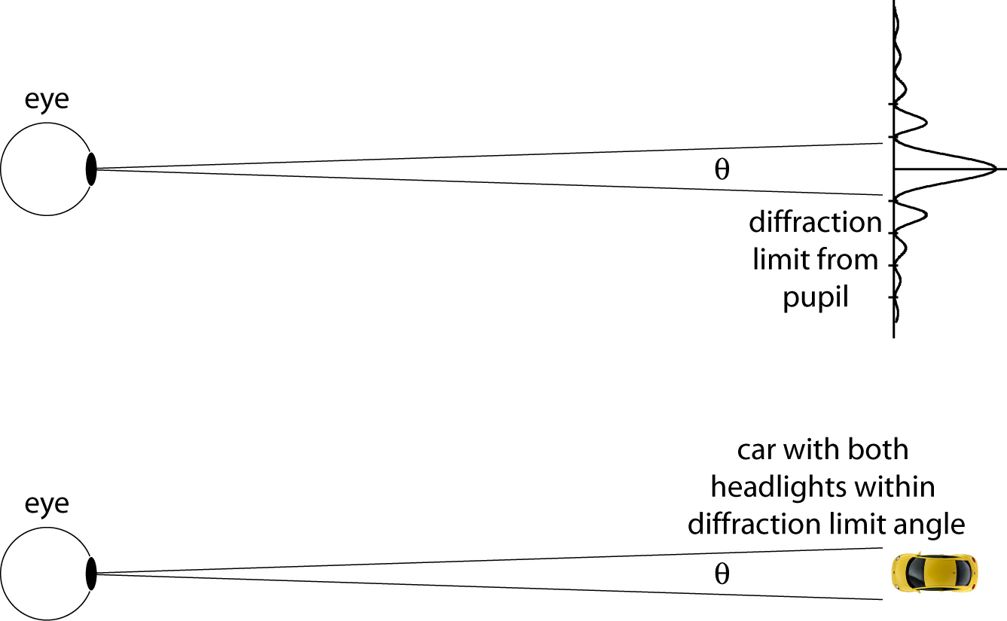
Let's measure the resolving power of your eyes to see how close your vision is to "perfect", that is, let's examine diffraction-limited performance.
Fig 1. Diffraction limit: Two headlights would be unresolvable, and would look like a single blurred light.

Diffraction effects limit the resolution of any optical instrument to an angle $q@\frac{λ}{D}$, where λ is the wavelength of the light used, and D is the diameter of the light-gathering optical element (e.g. the pupil of your eye). This limit is the angular size of the smallest thing you can see. Any details smaller than this blur together even if you have excellent ("perfect") vision.
1) Measure the diameter D of the pupil of your eye (in normal room-light). With one eye open, look closely at the image of your pupil in a mirror and measure your pupil's diameter with a clear plastic ruler placed on the mirror or over your eye. Record it here:

2) Measure the angular resolution of your eye: Your partner will stand on a "zero position" mark on the floor far away and will hold up an eye-test chart for you to view. The chart consists of an array of vertical or horizontal bars (next page). Beyond a certain distance, the human eye cannot resolve the bars due to diffraction effects, and the arrays appear as unresolved gray blotches rather than stripes. Begin by standing so far that the chart cannot possibly be resolved, and signal your partner to hold up the chart with either the vertical bars or the horizontal bars to your right. You should not know which orientation is used! Slowly, approach your partner, and when you can first resolve the bars, indicate with hand signals which side has the horizontal bars. Repeat several times, varying your distance. Each time, your partner should give a thumbs-up (correct) or thumbs-down (incorrect). (Turn away briefly while your partner randomly rearranges the chart for the next test.) Find the maximum distance L (marked on the floor) at which you can consistently read the chart correctly. The center-to-center separation x of the bars is marked on the chart.
- Record the maximum distance L here:
- The angle θ you can resolve is θ = x/L.
- Record this in radians and in degrees, here:
- Compare this angle with the theoretical diffraction-limited resolution of θ = λ /D.
Use λ = 550 nm (middle of the visible spectrum). How close are your vision and your partners' vision to "perfect"?

7.45 mm center-to-center distance

